MEMORY MANAGEMENT

Memory management is the functionality of an operating system which handles or manages primary memory and moves processes back and forth between main memory and disk during execution.
Memory management keeps track of each and every memory location, regardless of either it is allocated to some process or it is free.
It checks how much memory is to be allocated to processes.
It decides which process will get memory at what time. It tracks whenever some memory gets freed or unallocated and correspondingly it updates the status.
The part of OS that manages the memory hierarchy is called memory manager.
    - Keeps track of used/unused part of memory.
    - Allocate/de-allocate memory to processes.
    - Manages swapping between main memory and disk.
    - Protection and sharing of memory

Memory Hierarchy
Memory Hierarchy helps in optimizing the memory available in the computer. There are multiple levels present in the memory, each one having a different size, different cost, etc. Some types of memory like cache, and main memory are faster as compared to other types of memory but they are having a little less size and are also costly whereas some memory has a little higher storage value, but they are a little slower. Accessing of data is not similar in all types of memory, some have faster access whereas some have slower access.
Types of Memory Hierarchy
This Memory Hierarchy Design is divided into 2 main types:
- External Memory or Secondary Memory: Comprising of Magnetic Disk, Optical Disk, and Magnetic Tape i.e. peripheral storage devices which are accessible by the processor via an I/O Module.
- Internal Memory or Primary Memory: Comprising of Main Memory, Cache Memory & CPU registers. This is directly accessible by the processor.
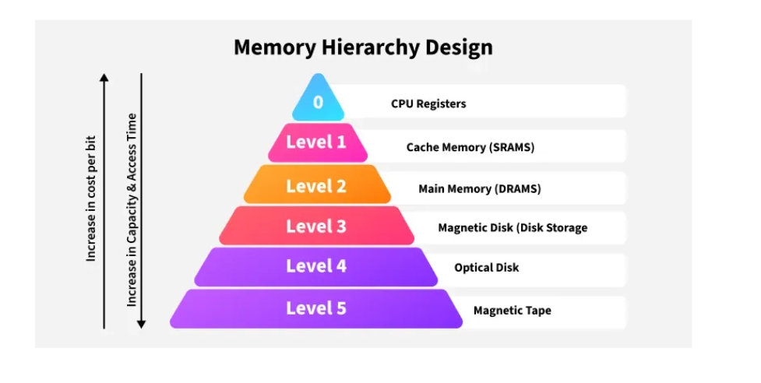
Memory Hierarchy Design
1. Registers
Registers are small, high-speed memory units located in the CPU. They are used to store the most frequently used data and instructions. Registers have the fastest access time and the smallest storage capacity, typically ranging from 16 to 64 bits.
2. Cache Memory
Cache memory is a small, fast memory unit located close to the CPU. It stores frequently used data and instructions that have been recently accessed from the main memory. Cache memory is designed to minimize the time it takes to access data by providing the CPU with quick access to frequently used data.
3. Main Memory
Main memory, also known as RAM (Random Access Memory), is the primary memory of a computer system. It has a larger storage capacity than cache memory, but it is slower. Main memory is used to store data and instructions that are currently in use by the CPU.
Types of Main Memory
- Static RAM: Static RAM stores the binary information in flip flops and information remains valid until power is supplied. Static RAM has a faster access time and is used in implementing cache memory.
- Dynamic RAM: It stores the binary information as a charge on the capacitor. It requires refreshing circuitry to maintain the charge on the capacitors after a few milliseconds. It contains more memory cells per unit area as compared to
4. Secondary Storage
Secondary storage, such as hard disk drives (HDD) and solid-state drives (SSD) , is a non-volatile memory unit that has a larger storage capacity than main memory. It is used to store data and instructions that are not currently in use by the CPU. Secondary storage has the slowest access time and is typically the least expensive type of memory in the memory hierarchy.
5. Magnetic Disk
Magnetic Disks are simply circular plates that are fabricated with either a metal or a plastic or a magnetized material. The Magnetic disks work at a high speed inside the computer and these are frequently used.
6. Magnetic Tape
Magnetic Tape is simply a magnetic recording device that is covered with a plastic film. Magnetic Tape is generally used for the backup of data. In the case of a magnetic tape, the access time for a computer is a little slower and therefore, it requires some amount of time for accessing the strip.
Characteristics of Memory Hierarchy
- Capacity: It is the global volume of information the memory can store. As we move from top to bottom in the Hierarchy, the capacity increases.
- Access Time: It is the time interval between the read/write request and the availability of the data. As we move from top to bottom in the Hierarchy, the access time increases.
- Performance: The Memory Hierarch design ensures that frequently accessed data is stored in faster memory to improve system performance.
- Cost Per Bit: As we move from bottom to top in the Hierarchy, the cost per bit increases i.e. Internal Memory is costlier than External Memory.

Storage Allocation

The process of allocating the block of memory to a process is known as storage allocation. Memory is a large array of bytes, where each byte has its own address. The memory allocation can be classified into two methods:

Contiguous Memory Allocation

The Contiguous memory allocation is one of the methods of memory allocation. In contiguous memory allocation, when a process requests for the memory, a single contiguous section of memory blocks is assigned to the process according to its requirement.

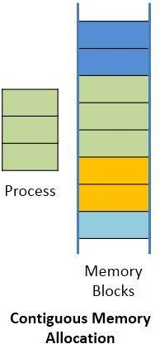

The contiguous memory allocation can be achieved by dividing the memory into the fixed- sized partition and allocate each partition to a single process only.
But this will cause the degree of multiprogramming, bounding to the number of fixed partition done in the memory.
The contiguous memory allocation also leads to the internal fragmentation.
Like, if a fixed sized memory block allocated to a process is slightly larger than its requirement then the left over memory space in the block is called internal fragmentation. When the process residing in the partition terminates the partition becomes available for the another process.

In the variable partitioning scheme, the operating system maintains a table which indicates, which partition of the memory is free and which occupied by the processes.

Non-contiguous memory

The Non-contiguous memory allocation allows a process to acquire the several memory blocks at the different location in the memory according to its requirement.
The noncontiguous memory allocation also reduces the memory wastage caused due to internal and external fragmentation. As it utilizes the memory holes, created during internal and external fragmentation.

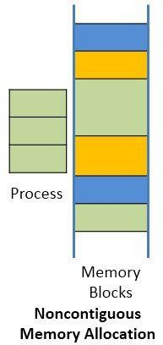

The noncontiguous memory allocation has an advantage of reducing memory wastage but, but it increases the overheads of address translation.

As the parts of the process are placed in a different location in memory, it slows the execution of the memory because time is consumed in address translation.

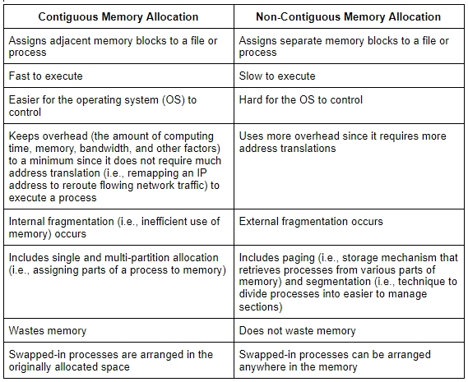

Partitioning( This partition scheme is known as memory management without swaping
Partitioning is the process of breaking the main memory into number of blocks. Partitioning is of two type:
- Fixed/Static Partition Allocation
- Variable/Dynamic Partition Allocation

Fixed/Static Partition Allocation
The simplest way to manage the memory available for the processes is to partition it into regions with fixed boundaries.

The partition may be equal sized or unequal sized
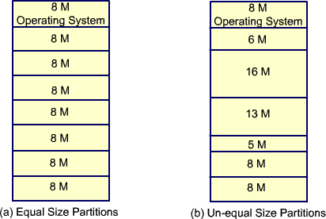
    - A process whose size is less than or equal to the partition size can be loaded into that partition
    - Main memory utilization is extremely inefficient.
    - Any program, no matter how small, occupies an entire partition. This phenomenon, in which there is wasted space internal to a partition due to the fact that the block of data loaded is smaller than the partition, is referred to as internal fragmentation.
    - Inefficient use of Memory due to internal fragmentation.

Dynamic partitioning

    - To overcome some of the difficulties with fixed partitioning, an approach known as dynamic partitioning was developed
    - The partitions are of variable length and number. When a process is brought into main memory, it is allocated exactly as much memory as it requires and no more
    - Holes (pieces of free memory) might be created during dynamic partitioning.
    - Given a new process, the OS must decide which hole to use for new process
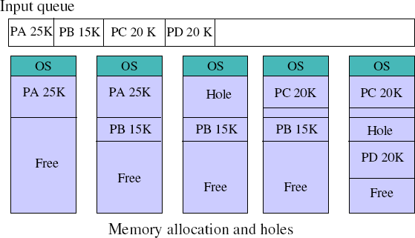

      - Frequent loading and unloading of programs causes free space to be broken into little pieces
      - Eventually it leads to a situation in which there are a lot of small holes in memory. As time goes on memory becomes more and more fragmented, and memory utilization declines. This phenomenon is referred to as external fragmentation.
      - External fragmentation exists when there is enough memory to fit a process in memory, but the space is not contiguous.

Bit Map for Dynamic Partitioning
The Main concern for dynamic partitioning is keeping track of all the free and allocated partitions. However, the Operating system uses following data structures for this task.
- Bit Map
- Linked List
Bit Map is the least famous data structure to store the details. In this scheme, the main memory is divided into the collection of allocation units. One or more allocation units may be allocated to a process according to the need of that process. However, the size of the allocation unit is fixed that is defined by the Operating System and never changed. Although the partition size may vary but the allocation size is fixed.
The main task of the operating system is to keep track of whether the partition is free or filled. For this purpose, the operating system also manages another data structure that is called bitmap.
The process or the hole in Allocation units is represented by a flag bit of bitmap. In the image shown below, a flag bit is defined for every bit of allocation units. However, it is not the general case, it depends on the OS that, for how many bits of the allocation units, it wants to store the flag bit.
The flag bit is set to 1 if there is a contiguously present process at the adjacent bit in allocation unit otherwise it is set to 0.
A string of 0s in the bitmap shows that there is a hole in the relative Allocation unit while the string of 1s represents the process in the relative allocation unit.
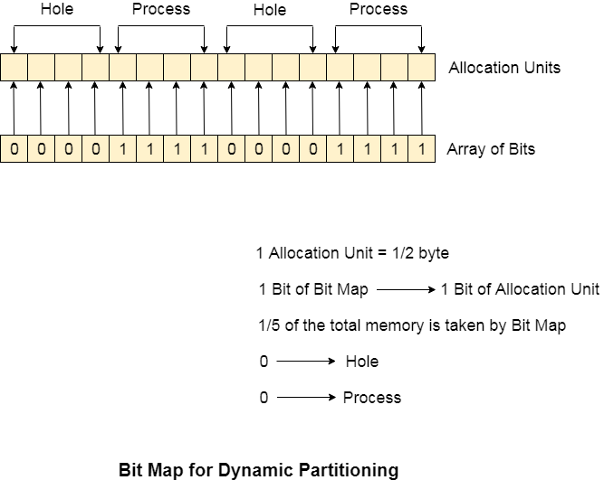
Disadvantages of using Bitmap
1. The OS has to assign some memory for bitmap as well since it stores the details about allocation units. That much amount of memory cannot be used to load any process therefore that decreases the degree of multiprogramming as well as throughput.
In the above image,
The allocation unit is of 4 bits that is 0.5 bits. Here, 1 bit of the bitmap is representing 1 bit of allocation unit.
- Size of 1 allocation unit = 4 bits
- Size of bitmap = 1/(4+1) = 1/5 of total main memory.
Therefore, in this bitmap configuration, 1/5 of total main memory is wasted.
- To identify any hole in the memory, the OS need to search the string of 0s in the bitmap. This searching takes a huge amount of time which makes the system inefficient to some extent
Linked List for Dynamic Partitioning
The better and the most popular approach to keep track the free or filled partitions is using Linked List.
In this approach, the Operating system maintains a linked list where each node represents each partition. Every node has three fields.
- First field of the node stores a flag bit which shows whether the partition is a hole or some process is inside.
- Second field stores the starting index of the partition.
- Third filed stores the end index of the partition.
If a partition is freed at some point of time then that partition will be merged with its adjacent free partition without doing any extra effort.
There are some points which need to be focused while using this approach.
- The OS must be very clear about the location of the new node which is to be added in the linked list. However, adding the node according to the increasing order of starting index is suggestible.
- Using a doubly linked list will make some positive effects on the performance due to the fact that a node in the doubly link list can also keep track of its previous node.
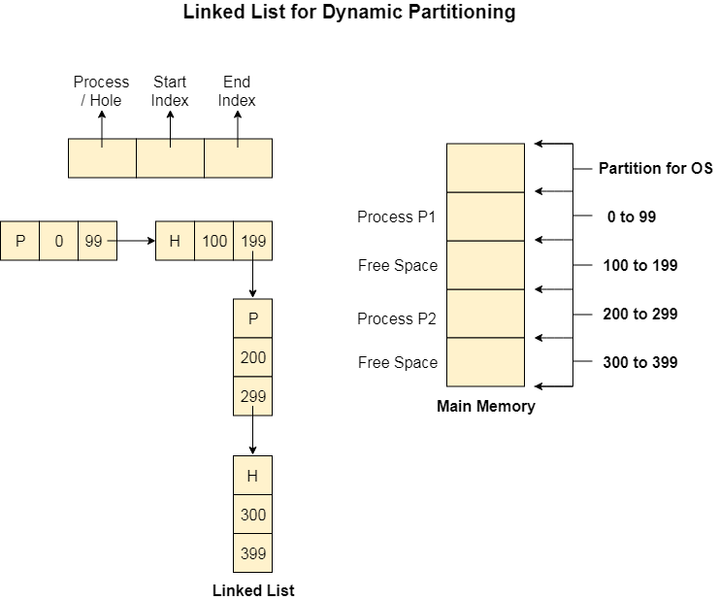

Logical Address
It is a virtual address generated by the CPU while a program is running. It is referred to as a virtual address because it does not exist physically. Using this address, the CPU access the actual address or physical address inside the memory, and data is fetched from there.
The hardware device called Memory Management Unit (MMU) is used for mapping this logical address to the physical address. The set of all logical addresses generated by the CPU for a program is called the logical address space.

Physical Address
Physical Address is the actual address of the data inside the memory. The logical address is a virtual address and the program needs physical memory for its execution. The user never deals with the Physical Address. The user program generates the logical address and is mapped to the physical address by the Memory Management Unit(MMU).
The set of all physical addresses corresponding to the logical addresses in the logical address space is called the physical address space.
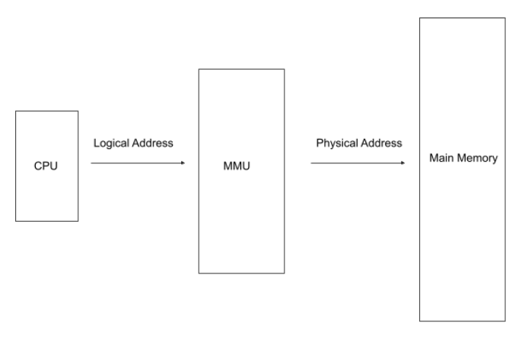
Differences between Logical Address and Physical Address :
- The Logical Address is generated by the CPU while the program is running and the Physical Address is the location inside the main memory.
- The Logical Address is Virtual and the Physical Address is the actual address of the memory.
- The Logical Address is generated by the CPU and the Physical Address is calculated by MMU.
- Users can't view the Logical Address of a program whereas the Physical Address is visible to the user.
- The set of all logical addresses generated by the CPU in reference to a program is called the Logical Address Space and the set of all physical addresses corresponding to the logical addresses in the Logical Address Space is called the Physical Address Space.

Realocation and protection

Memory management keeps track of the status of each memory location, whether it is allocated or free. It allocates the memory dynamically to the programs at their request and frees it for reuse when it is no longer needed. Memory management meant to satisfy some requirements that we should keep in mind.
These Requirements of memory management are:
- Relocation – The available memory is generally shared among a number of processes in a multiprogramming system, so it is not possible to know in advance which other programs will be resident in main memory at the time of execution of this program. Swapping the active processes in and out of the main memory enables the operating system to have a larger pool of ready-to-execute process.
When a program gets swapped out to a disk memory, then it is not always possible that when it is swapped back into main memory then it occupies the previous memory location, since the location may still be occupied by another process. We may need to relocate the process to a different area of memory. Thus there is a possibility that program may be moved in main memory due to swapping.
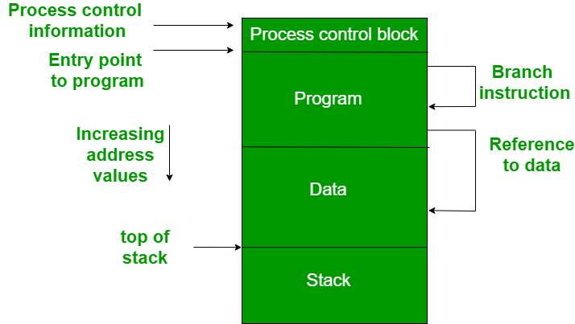
The figure depicts a process image. The process image is occupying a continuous region of main memory. The operating system will need to know many things including the location of process control information, the execution stack, and the code entry. Within a program, there are memory references in various instructions and these are called logical addresses.
After loading of the program into main memory, the processor and the operating system must be able to translate logical addresses into physical addresses. Branch instructions contain the address of the next instruction to be executed. Data reference instructions contain the address of byte or word of data referenced.
- Protection – There is always a danger when we have multiple programs at the same time as one program may write to the address space of another program. So every process must be protected against unwanted interference when other process tries to write in a process whether accidental or incidental. Between relocation and protection requirement a trade-off occurs as the satisfaction of relocation requirement increases the difficulty of satisfying the protection requirement.
Prediction of the location of a program in main memory is not possible, that’s why it is impossible to check the absolute address at compile time to assure protection. Most of the programming language allows the dynamic calculation of address at run time. The memory protection requirement must be satisfied by the processor rather than the operating system because the operating system can hardly control a process when it occupies the processor. Thus it is possible to check the validity of memory references.

Swapping(Memory management with swaping)
    - Swapping is a mechanism in which a process can be swapped temporarily out of main memory (or move) to secondary storage (disk) and make that memory available to other processes.
    - Backing store is a usually a hard disk drive or any other secondary storage which fast in access and large enough to accommodate copies of all memory images for all users. It must be capable of providing direct access to these memory images
    - At some later time, the system swaps back the process from the secondary storage to main memory.
    - Similar to round-robin CPU-scheduling algorithm, when a quantum expires, the memory manager will swap out that process to swap another process into the memory space that has been freed
    - The total time taken by swapping process includes the time it takes to move the entire process to a secondary disk and then to copy the process back to memory, as well as the time the process takes to regain main memory.

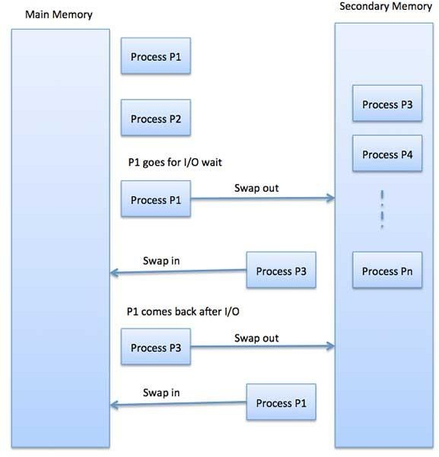

You can even explain this figure if u want to expand your answer

PAGING
- Paging is a memory management scheme by which a computer stores and retrieves data from secondary storage for use in main memory.
- Paging is a process of reading data from, and writing data to the secondary storage.
- Partition memory into small equal fixed-size chunks and divide each process into the same size chunks.
- The chunks of a process are called pages.
- The chunks of memory are called frames.

- The basic idea behind paging is to only keep those part of the processes in memory that are actually being used
- Paging is non-contiguous memory allocation technique.
- The basic idea behind paging is to only keep those part of the processes in memory that are actually being used
- Paging:
  - divides processes to a fixed sized pages
  - Then selectively allocates pages to frames in memory, and
  - manages (moves, removes, reallocates) pages in memory
- The logical memory of the process is still contiguous but the pages need not be allocated contiguously in memory
- By dividing the memory into fixed sized pages, we can eliminate external fragmentation
- However, paging dose not eliminate internal fragmentation (e.g4KB frame size and 15 KB of process)
- Summary: breaking process memory into fixed sized pages and map them to a physical frame of memory.
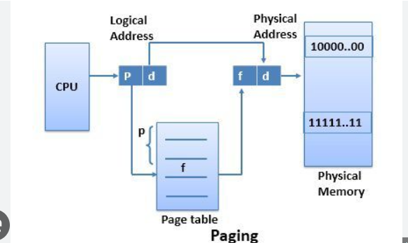

The basic terms

Page Fault
- When the page (data) requested by a program is not available in the memory, it is called as a page fault. This usually results in the application being shut down.
- A page is a fixed length memory block used as a transferring unit between physical memory and an external storage. A page fault occurs when a program accesses a page that has been mapped in address space, but has not been loaded in the physical memory.

Page hit
Whenever a process refers to a page that is present in memory, such condition is known as page hit.

Page table
A page table is the data structure used by a virtual memory system in a computer operating system to store the mapping between virtual addresses and physical addresses

Frame
Frame is a fixed sized block in physical memory space.

The different page replacement algorithm have already taught in class

Structure of Page Table in Operating Systems

The data structure that is used by the virtual memory system in the operating system of a computer in order to store the mapping between physical and logical addresses is commonly known as Page Table.
As we had already told you that the logical address that is generated by the CPU is translated into the physical address with the help of the page table.
- Thus page table mainly provides the corresponding frame number (base address of the frame) where that page is stored in the main memory.
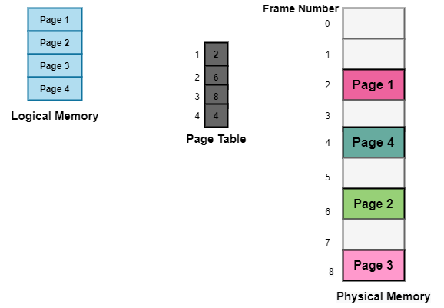
The above diagram shows the paging model of Physical and logical memory.
Characteristics of the Page Table
Some of the characteristics of the Page Table are as follows:
- It is stored in the main memory.
- Generally; the Number of entries in the page table = the Number of Pages in which the process is divided.
- PTBR means page table base register and it is basically used to hold the base address for the page table of the current process.
- Each process has its own independent page table.
Techniques used for Structuring the Page Table
Some of the common techniques that are used for structuring the Page table are as follows:
- Hierarchical Paging
- Hashed Page Tables
- Inverted Page Tables

Hierarchical Paging
Another name for Hierarchical Paging is multilevel paging.
- There might be a case where the page table is too big to fit in a contiguous space, so we may have a hierarchy with several levels.
- In this type of Paging the logical address space is broke up into Multiple page tables.
- Hierarchical Paging is one of the simplest techniques and for this purpose, a two-level page table and three-level page table can be used.
Two Level Page Table
Consider a system having 32-bit logical address space and a page size of 1 KB and it is further divided into:
- Page Number consisting of 22 bits.
- Page Offset consisting of 10 bits.
As we page the Page table, the page number is further divided into :
- Page Number consisting of 12 bits.
- Page Offset consisting of 10 bits.
Thus the Logical address is as follows:
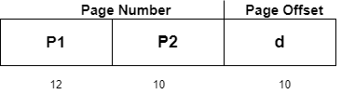
In the above diagram,
P1 is an index into the Outer Page table.
P2 indicates the displacement within the page of the Inner page Table.
As address translation works from outer page table inward so is known as forward-mapped Page Table.
Below given figure below shows the Address Translation scheme for a two-level page table
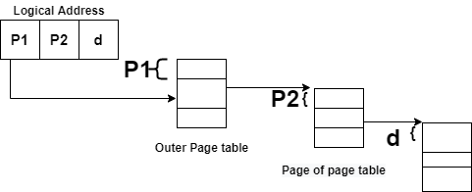
Three Level Page Table
For a system with 64-bit logical address space, a two-level paging scheme is not appropriate. Let us suppose that the page size, in this case, is 4KB.If in this case, we will use the two-page level scheme then the addresses will look like this:
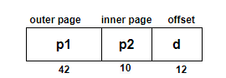
Thus in order to avoid such a large table, there is a solution and that is to divide the outer page table, and then it will result in a Three-level page table:
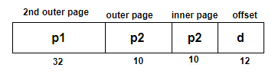
Hashed Page Tables
This approach is used to handle address spaces that are larger than 32 bits.
- In this virtual page, the number is hashed into a page table.
- This Page table mainly contains a chain of elements hashing to the same elements.
Each element mainly consists of :
- The virtual page number
- The value of the mapped page frame.
- A pointer to the next element in the linked list.
Given below figure shows the address translation scheme of the Hashed Page Table:
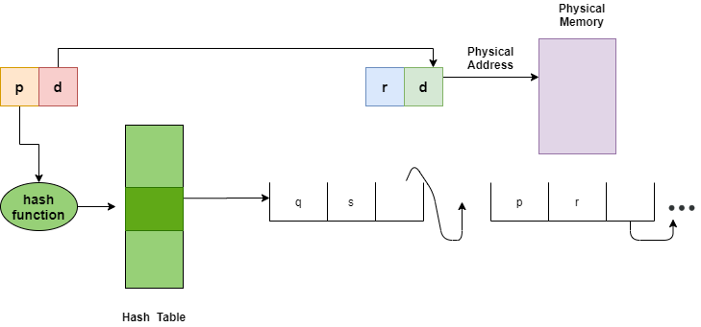
The above Figure shows Hashed Page Table
The Virtual Page numbers are compared in this chain searching for a match; if the match is found then the corresponding physical frame is extracted.
In this scheme, a variation for 64-bit address space commonly uses clustered page tables.
Clustered Page Tables
- These are similar to hashed tables but here each entry refers to several pages (that is 16) rather than 1.
- Mainly used for sparse address spaces where memory references are non-contiguous and scattered

Inverted Page Tables
The Inverted Page table basically combines A page table and A frame table into a single data structure.
- There is one entry for each virtual page number and a real page of memory
- And the entry mainly consists of the virtual address of the page stored in that real memory location along with the information about the process that owns the page.
- Though this technique decreases the memory that is needed to store each page table; but it also increases the time that is needed to search the table whenever a page reference occurs.
Given below figure shows the address translation scheme of the Inverted Page Table:
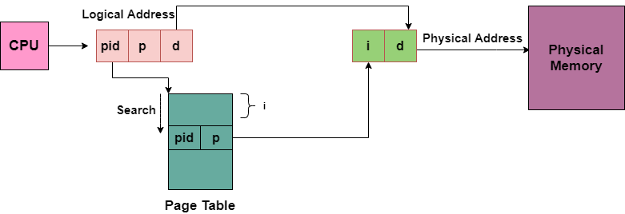
In this, we need to keep the track of process id of each entry, because many processes may have the same logical addresses.
Also, many entries can map into the same index in the page table after going through the hash function. Thus chaining is used in order to handle this.

Virtual memory
    - Virtual memory is a memory management technique that allows programs larger than physical memory to be executed.

    - A computer can address more memory than the amount physically installed on the system. This extra memory is actually called virtual memory.
    - The run time mapping from virtual address to physical address is done by hardware device called memory management unit (MMU).
    - Virtual Memory is a space where large programs can store themselves in form of pages while their execution and only the required pages or portions of processes are loaded into the main memory

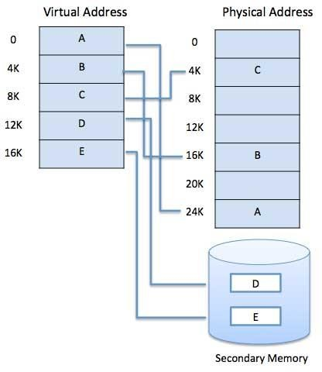
Virtual memory takes the advantage of the fact that processes typically do not use all the allocated memory. In other words, most processes never need all their pages at once.

Memory Mapping
The translation between the logical address space and the physical memory is known as Memory Mapping. To translate from logical to a physical address, to aid in memory protection also to enable better management of memory resources are objectives of memory mapping.
During cache mapping, the block is not brought from the main memory but the main memory block is simply copied to the cache. Cache memory generally tends to operate in some different configurations,
- Direct mapping
- Fully associative mapping
- Set associative mapping
1) Direct Mapping
In Direct mapped cache memory, each block mapped to exactly one location in cache memory.
A particular block of main memory can map the line number of cache is given by - Cache line number = (Block Address of Main Memory) modulo (Number of lines in Cache).
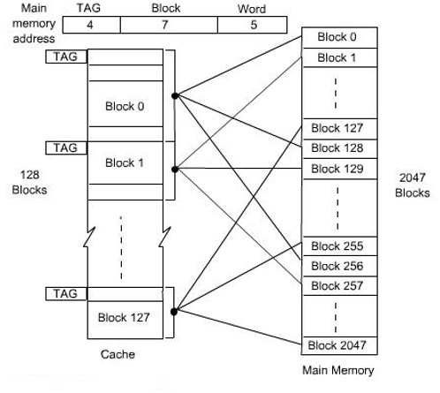
The direct-mapped cache is like rows in a table with three columns' main memory address are bits for Offset, Index, and Tag. The size of the fields depends on the capacity of memory and size of the block in the cache.
The least significant w bits are used to identify a word within a block of main memory. Tag corresponds to the remaining bits are used to determine the proper block of main memory. Line off-set or block is used to select a block to be accessed out of total blocks are available according to the capacity of the cache.

TLB
The Translation Lookaside Buffer (TLB) in an operating system is a hardware component that serves as a cache for the virtual-to-physical address translation process. It stores a subset of recently used virtual memory page mappings, making it faster to translate virtual addresses generated by programs into corresponding physical addresses in main memory (RAM). When a program accesses memory, the TLB is consulted, and if it contains the necessary translation, this results in a TLB hit, which significantly speeds up memory access.

Need of TLB
The Translation Lookaside Buffer (TLB) is needed in computer systems, particularly in the context of virtual memory and memory management, for several crucial reasons:

- Faster Memory Access:
When a program accesses memory, a TLB hit can provide the required translation almost instantly, reducing the time it takes to fetch data from main memory (RAM). This leads to faster program execution and improved system performance.
- Efficient Use of Memory:
Virtual memory systems allow programs to access more memory than physically available. This reduces contention for memory resources and improves overall system efficiency.
- Reduced Power Consumption:
Accessing main memory consumes more power compared to accessing the TLB.
- Minimized Page Table Access:
Without TLB, every virtual-to-physical address translation would require accessing the page table in main memory, which can be time-consuming.
- Improved System Responsiveness:
TLB helps in maintaining the system's responsiveness. It ensures that memory access operations, which are fundamental to program execution, are as quick as possible, reducing perceived delays and ensuring a smoother user experience.

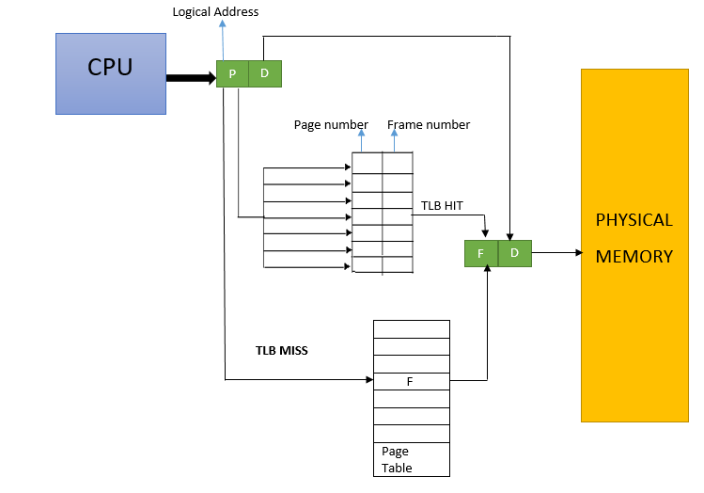
Steps in TLB
1. CPU Generates a Virtual Address
- The CPU generates a virtual address that needs to be translated into a physical address.
2. Extract Page Number and Offset
- The virtual address is divided into two parts:
  - Page number: Identifies the page in the virtual memory.
  - Offset: Specifies the location within the page.
3. Search the TLB
- The page number is searched in the TLB:
  - TLB hit: If the page number is found, the corresponding frame number (physical page number) is fetched.
  - TLB miss: If the page number is not found, the system proceeds to access the page table in memory.
4. Handle TLB Hit
- If the TLB hit occurs:
  - Combine the frame number from the TLB with the offset from the virtual address.
  - Generate the physical address.
  - Use the physical address to access memory.
5. Handle TLB Miss
- If the TLB miss occurs:
  - Access the page table in main memory to find the corresponding frame number.
  - If the page is not in physical memory (page fault):
    - Load the page from disk into physical memory.
    - Update the page table.
  - Update the TLB with the new mapping (page number to frame number).
6. Replace an Entry in the TLB (if full)
- If the TLB is full, apply a replacement policy (e.g., Least Recently Used - LRU, First In First Out - FIFO) to replace an existing entry with the new one.
7. Continue Execution
- The CPU continues execution using the translated physical address, either fetched from the TLB or the updated page table.

Demand Paging
Demand paging is a technique used in virtual memory systems where pages enter main memory only when requested or needed by the CPU. In demand paging, the operating system loads only the necessary pages of a program into memory at runtime, instead of loading the entire program into memory at the start. A page fault occurred when the program needed to access a page that is not currently in memory.
The operating system then loads the required pages from the disk into memory and updates the page tables accordingly. This process is transparent to the running program and it continues to run as if the page had always been in memory.
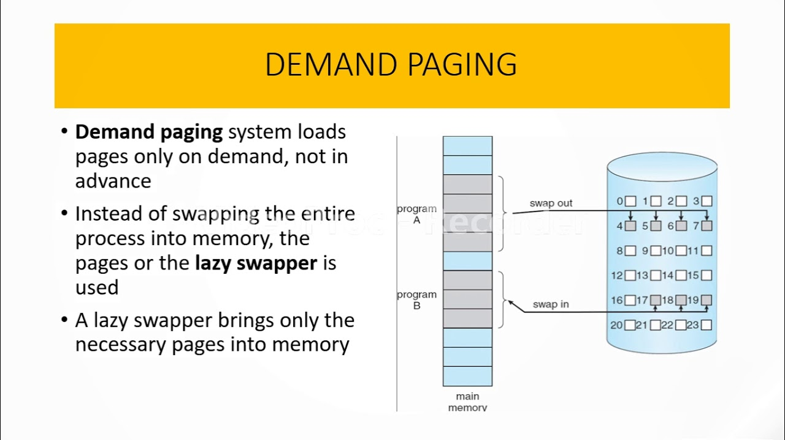

THRASHING
thrashing occurs when a computer's virtual memory resources are overused, leading to a constant state of paging and page faults, inhibiting most application-level processing. It causes the performance of the computer to degrade or collapse. The situation can continue indefinitely until the user closes some running applications or the active processes free up additional virtual memory resources.

Thrashing is when the page fault and swapping happens very frequently at a higher rate, and then the operating system has to spend more time swapping these pages. This state in the operating system is known as thrashing. Because of thrashing, the CPU utilization is going to be reduced or negligible.
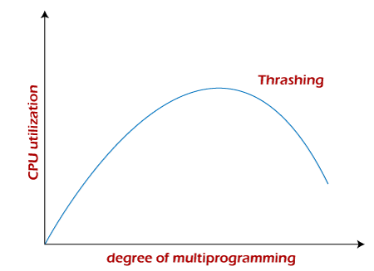
The basic concept involved is that if a process is allocated too few frames, then there will be too many and too frequent page faults. As a result, no valuable work would be done by the CPU, and the CPU utilization would fall drastically.
The long-term scheduler would then try to improve the CPU utilization by loading some more processes into the memory, thereby increasing the degree of multiprogramming. Unfortunately, this would result in a further decrease in the CPU utilization, triggering a chained reaction of higher page faults followed by an increase in the degree of multiprogramming, called thrashing.

Segmentation
    - Segmentation is a memory management technique in which each job is divided into several segments of different sizes, one for each module that contains pieces that perform related functions. Each segment is actually a different logical address space of the program.
    - When a process is to be executed, its corresponding segmentation are loaded into non- contiguous memory though every segment is loaded into a contiguous block of available memory.
    - Segmentation memory management works very similar to paging but here segments are of variable-length where as in paging pages are of fixed size.
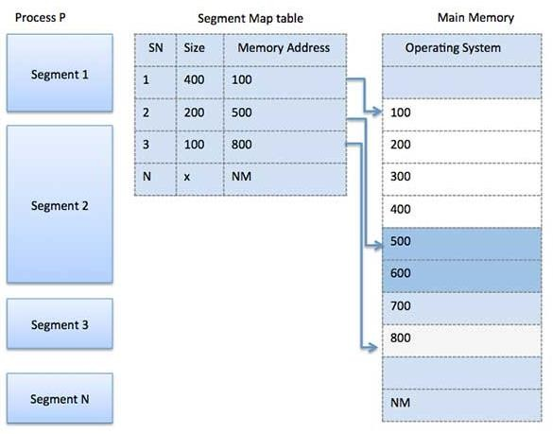
    - A program segment contains the program's main function, utility functions, data structures, and so on. The operating system maintains a segment map table for every process and a list of free memory blocks along with segment numbers, their size and corresponding memory locations in main memory. For each segment, the table stores the starting address of the segment and the length of the segment. A reference to a memory location includes a value that identifies a segment and an offset.
Fig: Segmentation

    - Segmentation is a technique to break memory into logical pieces where each piece represents a group of related information.
    - For example, data segments or code segment for each process, data segment for operating system and so on.
    - Segmentation can be implemented using or without using paging.
    - Unlike paging, segment are having varying sizes and thus eliminates internal fragmentation. External fragmentation still exists but to lesser extent.
    - Because of the use of unequal size segments, segmentation is similar to dynamic partitioning
    - Segmentation eliminates internal fragmentation but like dynamic partitioning, it suffers from external fragmentation

PAGING vs SEGMENTATION

COMPARISON | PAGING | SEGMENTATION
Basic | A page is of fixed block size. | A segment is of variable size.
Fragmentation | Paging may lead to internal fragmentation. | Segmentation may lead to external fragmentation.
Address | The user specified address is divided by CPU into a page number and offset. | The user specifies each address by two quantities a segment number and the offset (Segment limit).
Size | The hardware decides the page size. | The user specifies the segment size.
Table | Paging involves a page table  that contains base address of each page. | Segmentation involves the segment table  that contains segment number and offset (segment length).

Segmentation with paging
    - It allows to use segmentation from user’s point of view and also to divide each segment into pages of fixed size.
    - In a combined paging/segmentation system, a user’s address space is broken up into a number of segments. Each segment is broken up into a number of fixed-sized pages which are equal in length to a main memory frame
    - Segmentation is visible to the programmer
    - Paging is transparent to the programmer
    - Segments can be of different lengths, so it is harder to find a place for a segment in memory than a page. With segmented virtual memory, we get the benefits of virtual memory but we still have to do dynamic storage allocation of physical memory. In order to avoid this, it is possible to combine segmentation and paging into a two-level virtual memory system.

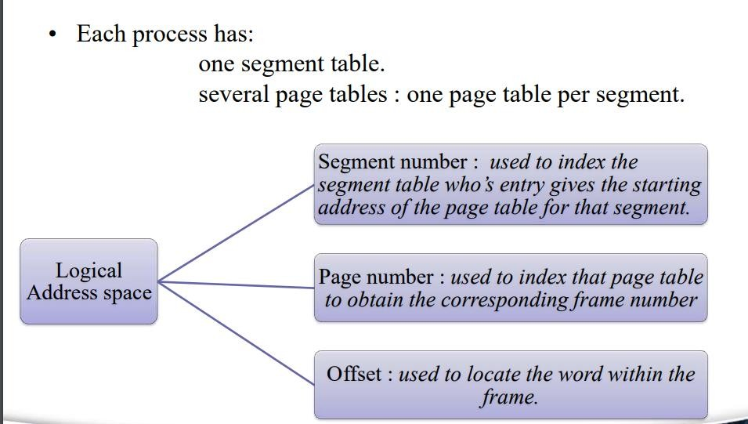
Each segment descriptor points to page table for that segment. This give some of the advantages of paging (easy placement) with some of the advantages of segments (logical division of the program).

Advantages
- Reduces memory usage as opposed to pure paging
  - Page table size limited by segment size
  - Segment table has only one entry per actual segment
- Share individual pages by copying page table entries.
- Share whole segments by sharing segment table entries, which is the same as sharing the page table for that segment.
- Most advantages of paging still hold
  - Simplifies memory allocation
  - Eliminates external fragmentation.
- In general, this system combines the efficiency in paging with the protection and sharing capabilities of the segmentation.

Coalescing
The process of merging two adjacent holes to form a single larger hole is called coalescing.
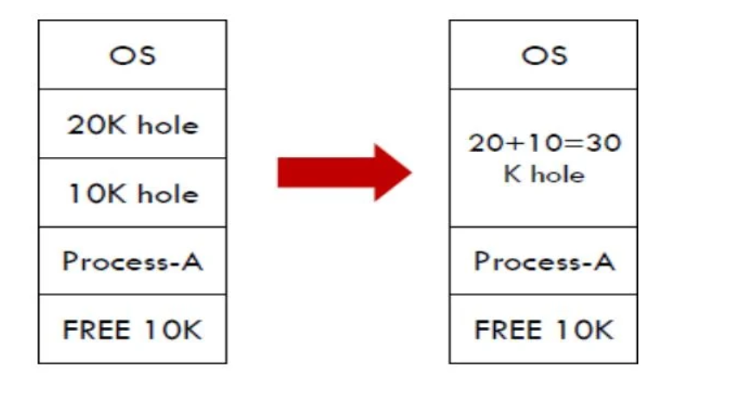

Compaction
Even when holes coalesce, no individual hole may be large enough to hold the job, although the sum of holes is larger than the storage required for a process. It is possible to combine all the holes into one big one by moving all the processes downward as far as possible; this technique is called memory compaction.

